**REPORT:**

The Big Mountain Resort is a ski resort located in Montana, that offers access to 105 trails. Every year 350,000 people visit Big Mountain. The resort is serviced by 11 lifts, 2 T-bars and 1 magic carpet. The longest run in Big Mountain is 3.3 miles, the base elevation is 4,464 ft and the summit is 6,817 ft with vertical drop of 2,353 ft.

Big Mountain resort charges $81 on both weekday and weekend. The current pricing strategy of Big Mountain is to charge a premium above the average price of other resorts in the market segment. There is a suspicion that Big Mountain is not capitalizing on its facilities as much as it could. The purpose of this report is to find out which facilities are more popular amongst the visitors and they are ready to pay more and accordingly come up with the pricing strategy for Big Mountain resort tickets. This model will be used to provide guidance for Big Mountain's pricing and future facility investment plans.

We have data of around 330 resorts across the states with the feature details like summit, vertical drop, longest run, number of lifts, ticket prices and much more. Montana is 3rd largest state and is also 4th in the list of density of resorts relative to population. Our aim is to find if there is any correlation between ticket price and the resort features. Lets refer the below heatmap for this:

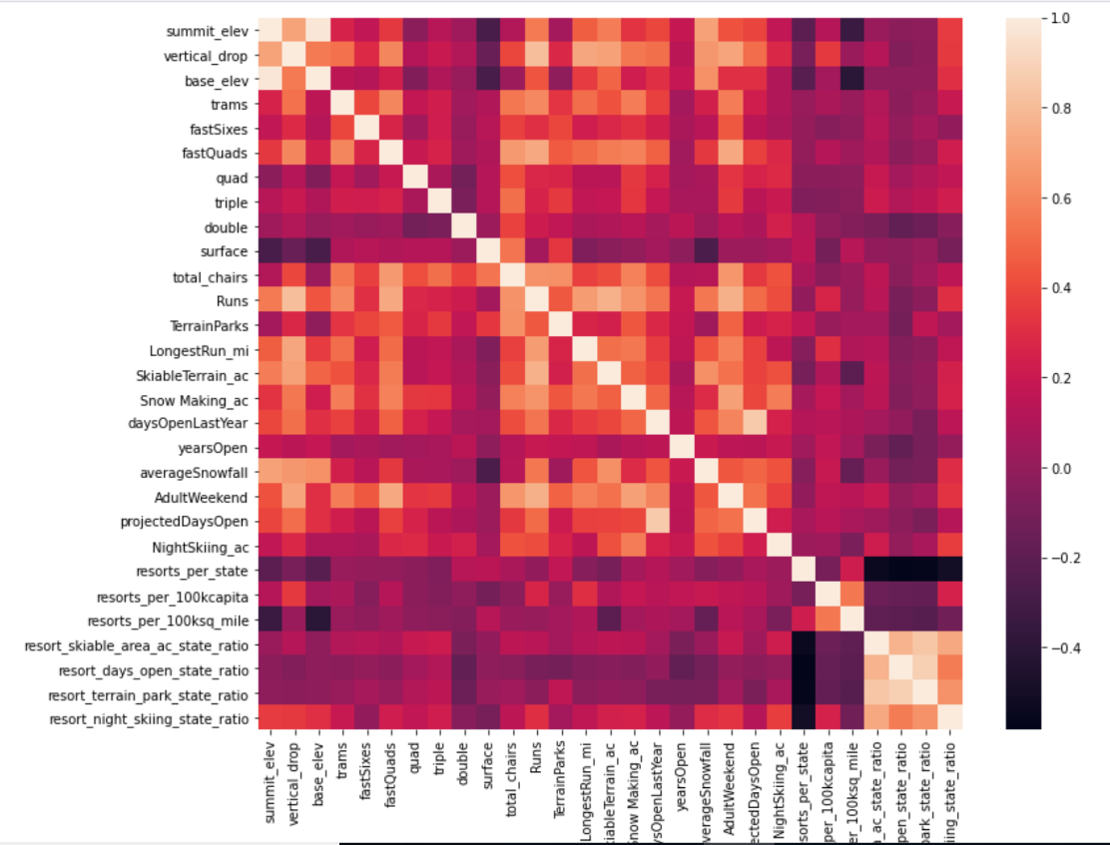

From this heatmap, we can see that there is a high correlation between ticket prices and features like vertical drop, fastQuads, Runs, total_chairs and Snow_making_ac. Skiable_terrain and longest_run are also fairly corelated with the prices.

Below is the representation of all price affecting features across states and the vertical line represents where Big Mountain stands in this distribution:

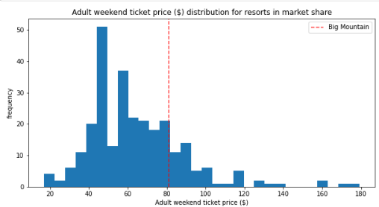 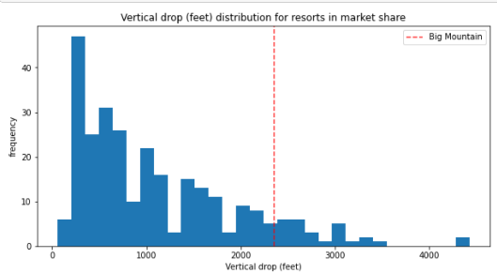 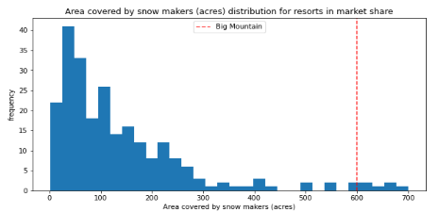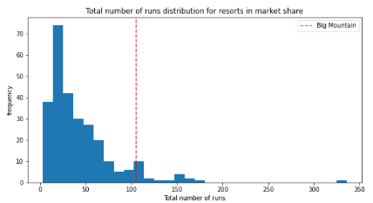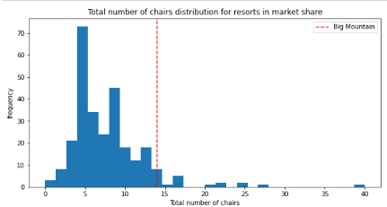

This shows that Big Mountain definitely stands out for some of the popular features. Big Mountain Resort has been reviewing potential scenarios for either cutting costs or increasing revenue from ticket prices. According to our pricing model, the ticket price can be raised up to $95.87.

After considering various scenarios, we have concluded that, Big mountain can close up to 5 least used runs while not dropping the ticket prices with large margins. However, if we have an additional run with vertical drop increased by 150 feet and install an additional chair lift, we can increase the ticket prices by $1.99. Over the season, this could be expected to raise up to $3474638. The operating cost of the chair lift would be $1,540,000, which will still have revenue increased by $1,934,638 by next season.